**Explication video simulation**

<https://youtu.be/eFJfKcCq5lo>

**Broker Port 8000**

**Broker Port 1884**

**WEB APPLICATION**

**SERVER**

**AUTOPILOT**

**MISSION PLANNER**

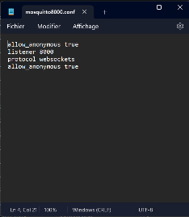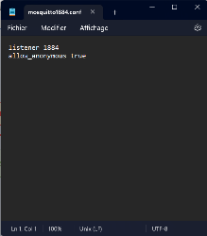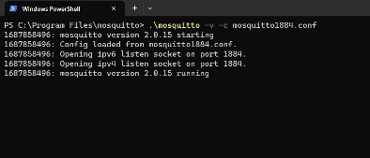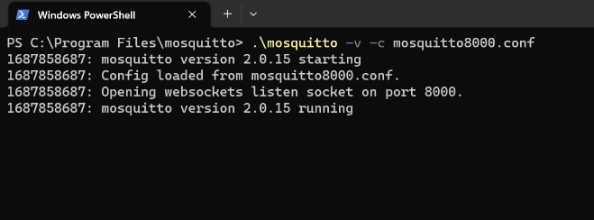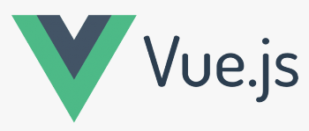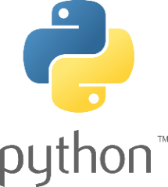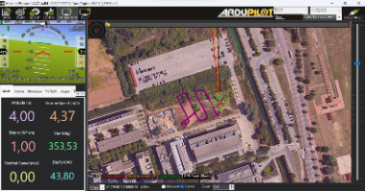

So, first of all, here's how the elements of the simulation are organized. We find the two brokers on two different ports. The web application in vue.js on Visual Studio Code, the server and autopilot in python on Pycharm.

We also opened Mission Planner to generate the simulation.

First, we need to make sure we've set the right IP addresses and ports on the various elements to be connected to the brokers.

In this simulation, we're only connecting to broker 8000 (external broker), so we need to activate the internal broker (1884) to ensure smooth communication between the simulation and the autopilot.

Step by step, we must first switch on the brokers, then launch the application server, the autopilot (note that autopilot runs under python 2.7) and the web application (npm run serve). Once this has been done, we can launch the Mission Planner simulation.

We can now check that the connection is working for the server (on the server, when the web page is opened, you need to refresh the page if it was opened before the server was launched).

Next, we need to connect the drone by clicking on the connect drone button on the web application, and check that the connection is effective.

Then we can create our flight plan as we wish and launch it.